I have assumption that once we released TR(task) then we can not revert TR to modiable, but that was wrong.

SAP have provided program using which we can do this.

Initially TR was in Released status.

**Step 1**: Go to SE38-> enter program name : RDDIT076 -> execute

[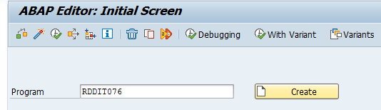](https://blogs.sap.com/wp-content/uploads/2016/01/pastedimage_2_862443.png)

**Step 2**: Enter TR/Task which status you want to convert from released to modifiable -> execute program

[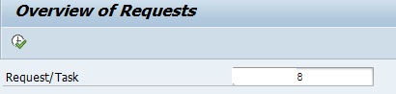](https://blogs.sap.com/wp-content/uploads/2016/01/pastedimage_3_862451.png)

**Step 3**: you will find TR with R (Released) status.

[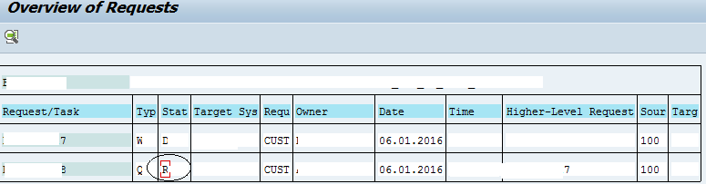](https://blogs.sap.com/wp-content/uploads/2016/01/pastedimage_0_862468.png)

double click on R status(encircled in above screen), you will find below screen where need to edit R status to D status(D= Modified).

[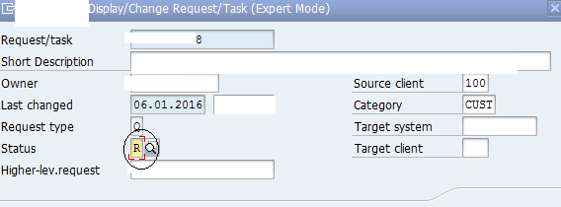](https://blogs.sap.com/wp-content/uploads/2016/01/pastedimage_6_862466.png)

click on Save. -> exit from program

**Step 4**: go to Se01-> enter TR name, you will find TR in unreleased(modifiable) status.

[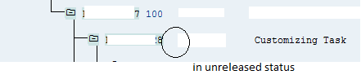](https://blogs.sap.com/wp-content/uploads/2016/01/pastedimage_7_862467.png)